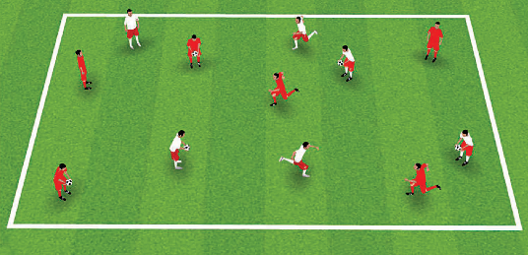
ACTIVITY 1: “LAST PLAYER STANDING”
2350 XX 2200 MMEETTRERESS

SET UP:Up to 12 players, in 2 teams. No ball to start.
  - Each player has a pinnie (or an old t-shirt) tucked into his/her shorts,
hanging down roughly to the hem of their shorts.

INSTRUCTIONS:
- “Go!” – run around the field and try to take all the opposing team’s pinnies by pulling them out of their shorts. The last player that still has a pinnie in their shorts gets a point for their team.

Progressions::
- Introduce 5 soccer balls: instead of taking pinnies, players can eliminate the other team by passing one of the balls and hitting an opposing team player below the knees (as in dodge ball).
- Combine the above exercises so that players can either take pinnies or pass to hit below the knee to eliminate opposing players.
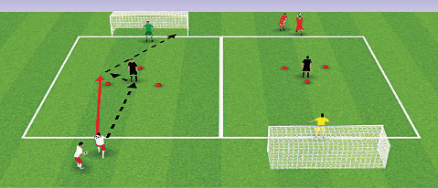
ACTIVITY 2: “BERMUDA TRIANGLE”
2350 XX 2200 MMEETTRERESS
2300MXET2R0EMCEHTAENRESL

SET UP: players, each with a ball, working in 2 teams; 1 goalkeeper.
  - Coach/parent stands inside a triangle marked out with cones.

INSTRUCTIONS: “Go!” – the first player in line throws the ball to the coach/parent. The coach/ parent catches the ball and rolls it to their left or right. The player chases the ball and shoots on goal, then runs to the back of the line.
  - “Ground pass!” – instead of throwing the ball, the player passes to the coach/ parent. The coach/parent passes it back just beyond the triangle. Players try to get the ball past the coach/parent in just one touch (with the inside or outside of the foot) before shooting.

Progressions: “Challenge!” – Put a player in the triangle rather than a coach/parent, and have them come out to challenge for the ball after passing it to the shooter. After one turn, the shooter moves to the triangle, and the player in the middle moves to the back of the line.
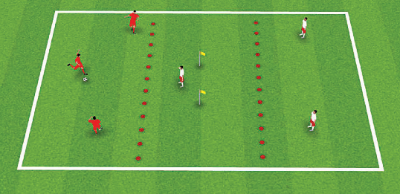
ACTIVITY 3: “SHOOT ON SIGHT”
2350 XX 2250 MMEETTRERESS

SET UP:Two teams of 3 players each.
  - Use cones to divide the field into 3 equal zones. In the middle zone, use 2 flags
or cones to mark out a goal. Team 1 players are the attackers and start with the ball. Team 2 players start as the defenders.

INSTRUCTIONS:“Go!” – one player from Team 2 goes into the middle zone as the goalkeeper. Team 1 tries to score. After each shot on goal (unless the shot rebounds back into the attacking team’s zone), the teams switch roles.
- Players must shoot from inside their zone.

Progressions::
- Teams get an extra point if they score a one-touch goal (i.e. pass to a teammate who shoots with his first touch).
- Add a defender to support the goalkeeper and create a 3 v 1 game.

Activity 4. Small Sided Game
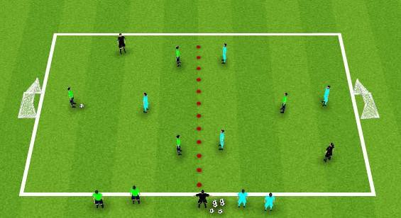
U6s 3v3 & U7s&U8s 4v4
- The focus of this Small Sided Game is to foster real time decisions and allow the players to PLAY
Encourage: Spreading Out in a Diamond or Triangle for U6s
- Staying High/Wide/Deep
- Keep their heads UP
Of Note:
Restarts from own end after goal Opposing team backs up past center line.
Kick ins when Ball goes out & First Pass is Free

