First Kicks Lesson Plans 2019
Sept 25 & 28

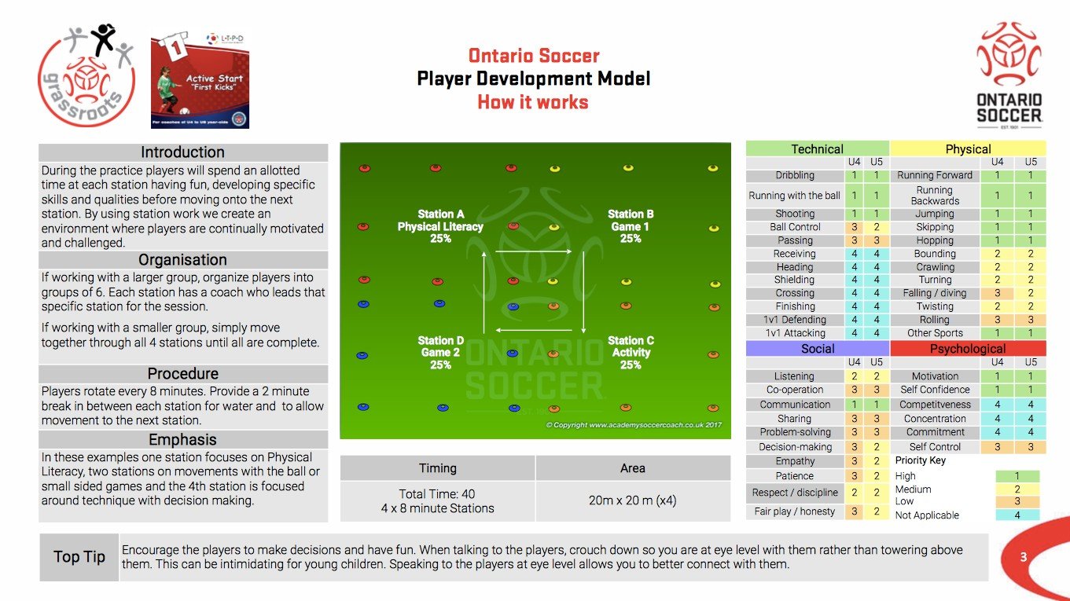

First Kicks Lesson Plans 2019
Sept 25 & 28
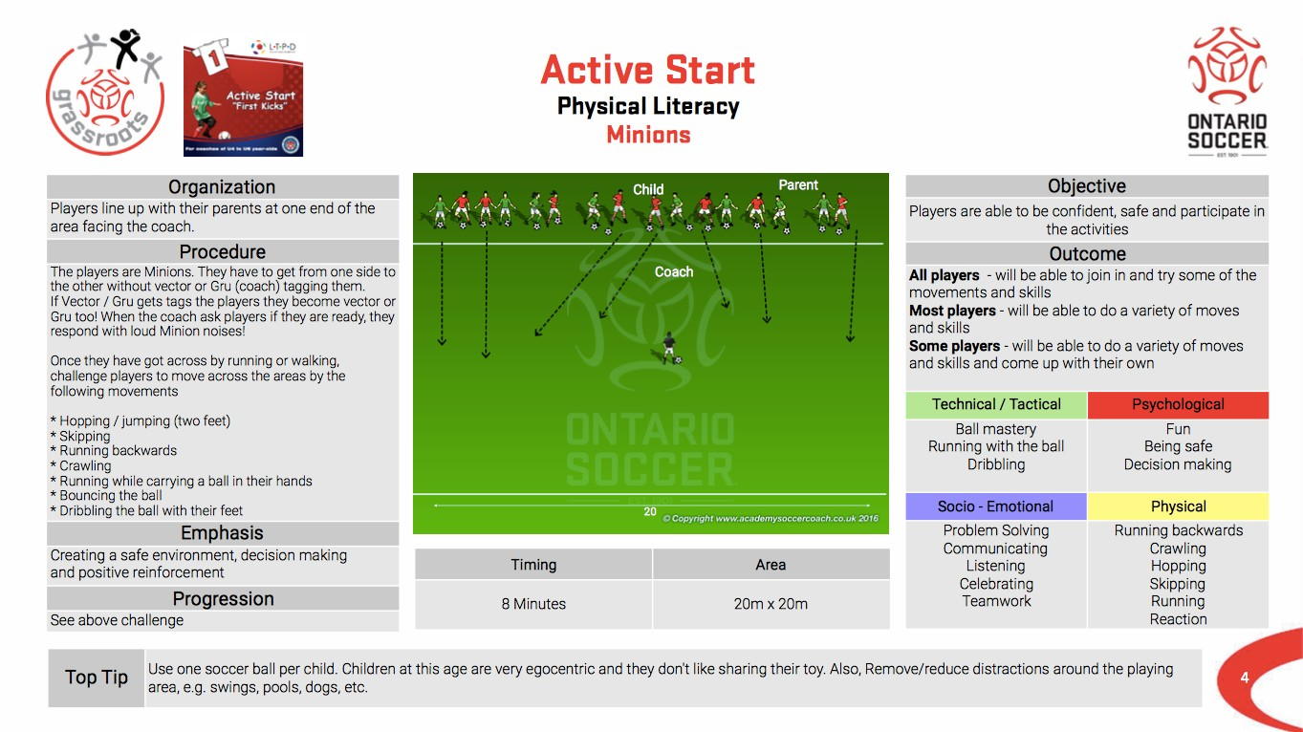

First Kicks Lesson Plans 2019
Sept 25 & 28
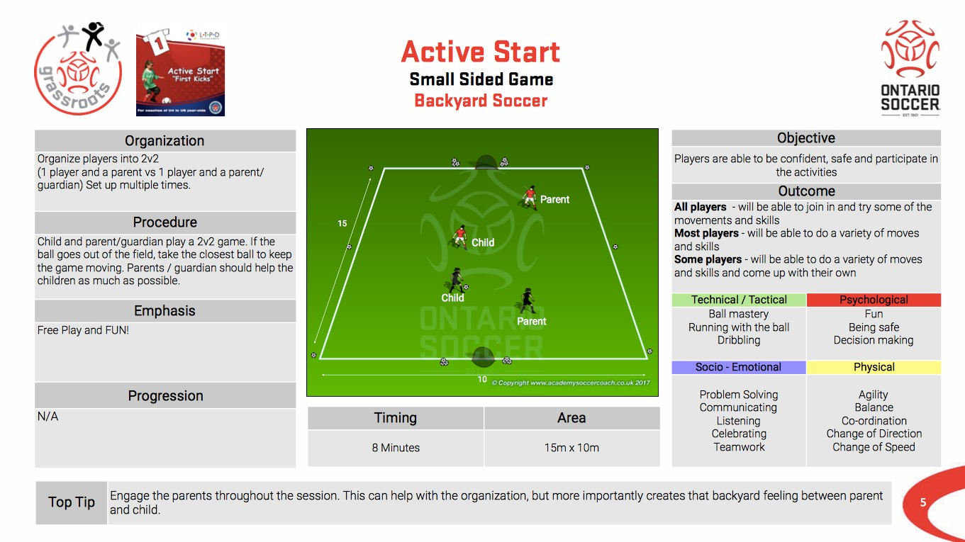

First Kicks Lesson Plans 2019
Sept 25 & 28
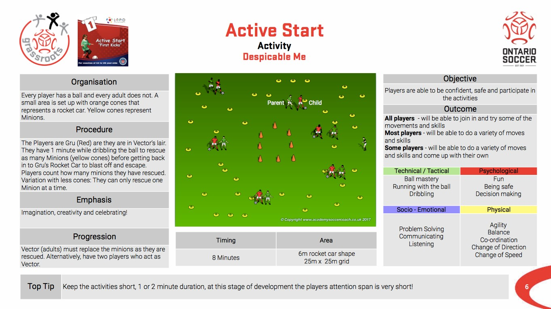

First Kicks Lesson Plans 2019
Sept 25 & 28
