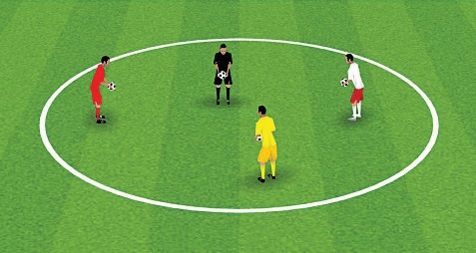
ACTIVITY 1: “COACH SAYS”
3200XM2E0TRYEDSS

SET UP:
  - Up to 12 players, each with a ball.

INSTRUCTIONS:
  - “Listen!” – when “coach says” do this, you do it. But if you don’t hear “coach says,” don’t do it!
  - “Coach says” throw the ball up and catch it; “coach says” throw the ball up, kick it and catch it; “coach says” use your other foot; etc.
OPTIONS: Instead of juggling, “coach says” drop the ball onto your foot and use the top of your foot like a pillow to gently lower the ball to the ground. “Coach says” use your other foot.

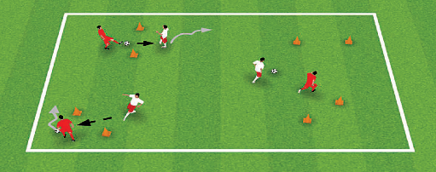
ACTIVITY 2: “THROUGH THE GATE”
3030X X2020MEYTDRSES

SET UP:
• Up to 12 players, working in pairs; one ball per pair.
• Use cones to create a series of gates spread out evenly around the field.

INSTRUCTIONS:
• “Go!” – players with the ball use their feet to move the ball around the field. Players without the ball stay close to their partner and call out their name when they’re in a good position to receive a pass. Score a point by passing the ball through a gate to your partner.
• “Set a record!” – see how many points you can score in one minute.

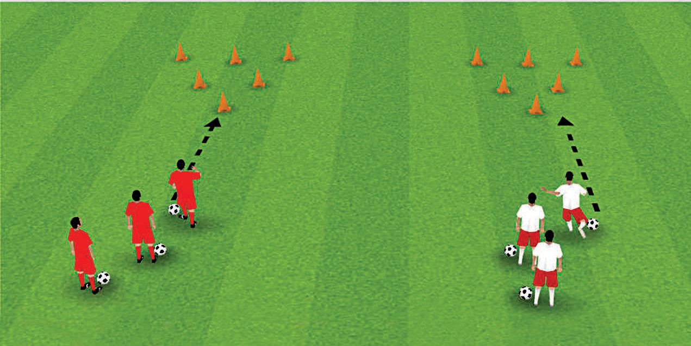
ACTIVITY 3: “BOWLING”

SET UP:
  - Up to 12 players, each with a ball.
  - 4 teams of 3 players each.

INSTRUCTIONS:
  - “Bowl!” – use your foot to pass the ball and knock over as many cones as you can. If you miss the cones, run to get your ball and dribble back to the start line before passing again.
  - When you’ve knocked over at least one cone, get your ball and dribble to the back of the line to wait your next turn.
The first team to knock down all the cones wins!

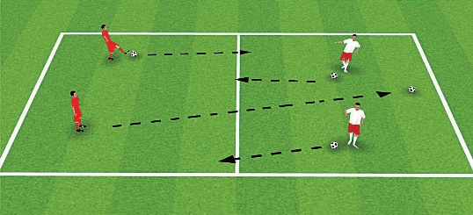
ACTIVITY 4: “CLEAN YOUR ROOM!”
3300 XX 2200 MMEETTRERESS

SET UP:
  - Up to 8 players, each with a ball.
  - In teams of four, with each team living in one “room.”

INSTRUCTIONS:
  - “Clean your room!” – pass your ball into your opponent’s room while keeping your own room tidy. If you see another player’s ball come into your room, pass it back across.
  - “Stop!” – Use the side of your foot to stop the ball. The team with the fewest balls in their room wins!

OPTIONS:
- Pass the ball with your other foot.
- If a ball goes too far and ends up outside the “room,” the coach takes it out of the game.

