Active Start Lesson Plans 2019/2020

**Sept 11**

**Dutch Circle Control & Turn**

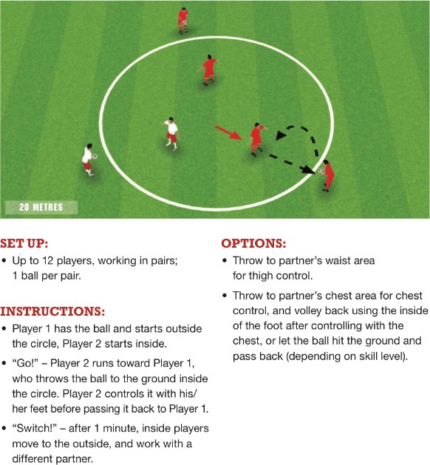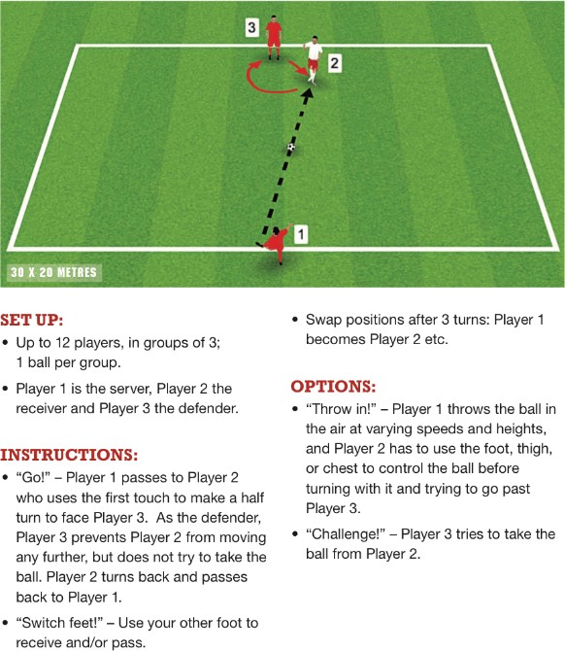

**Danger Zone Small Side Game**

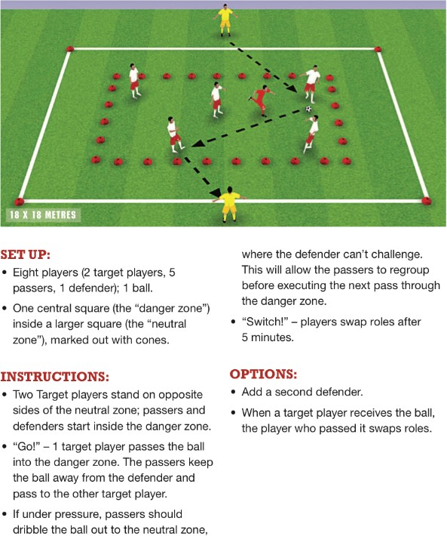

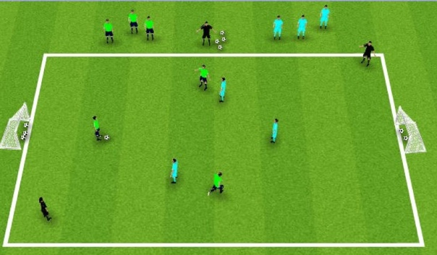

**Set Up:**

Regular Small Sided Games format

**Emphasis:**

Must complete 1-3 pull backs and passes to be able to score on goal

*\*U6s will play in a regular small sided game*