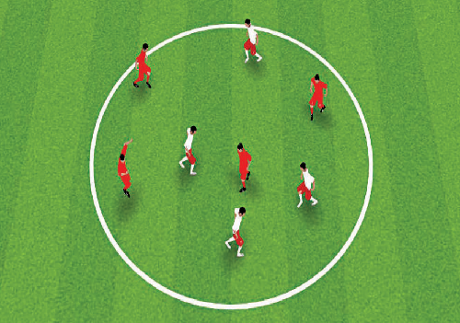
1.Coordination: “REACT—FAST!”
302X0 2M0ETMREETSERS

SET UP:Up to 12 players in a circle; no ball to start.

INSTRUCTIONS:“Go!” – players run freely around the circle.
“Listen!”– change the way you’re moving on the coach’s command:1.Run backwards. 2. Shuffle to the side. 3. Jump in place. 4. Sit down and get up fast; keep running. 5. Knees up. 6. Kick your heels back.7. Touch the inside of your foot, etc.

OPTIONS:Each player starts by dribbling a ball around the field.“Listen!” – 1. Turn and dribble in the other direction. 2. Dribble to the side. 3.Jump in place with the ball between your knees. 4. Throw the ball up and catch it. 5. Drop the ball, volley it with your thigh, then catch it, etc. Continue dribbling.

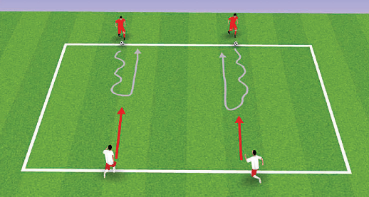
2.Soccer Technique: ACROSS THE CHANNEL
2300 XX 2200 MMEETTRERESS

SET UP:Up to 12 players, working in pairs; 1 ball per pair.

INSTRUCTIONS:“Go!” – Player 1 dribbles the ball across the channel towards Player 2.
-“Challenge!” – Player 2 tries to take the ball away before Player 1 can turn and dribble back. If Player 2 doesn’t win the ball, Player 1 gets a point. On the next turn, Player 2 starts with the ball and Player 1 challenges.
“Switch!” – rotate partners.

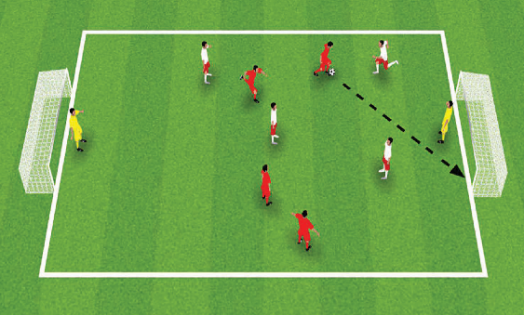
3.SMALL-SIDED GAMES:SOCCER RUGBY
3350 XX 3200 MMEETTRERESS

SET UP:Two teams of 4 players plus 2 goalkeepers.

INSTRUCTIONS:“Go!” – proceed with a normal soccer game but players can’t pass the ball forward, they can only dribble forward before shooting on goal. Teammates provide support from behind or beside the dribbler (i.e., they find open space to receive a pass), as in rugby.

OPTIONS:1.Rotate goalkeepers.
2.Anattacking player must dribble past at least one defender before shooting on goal.

4.Regular Small Sided Game
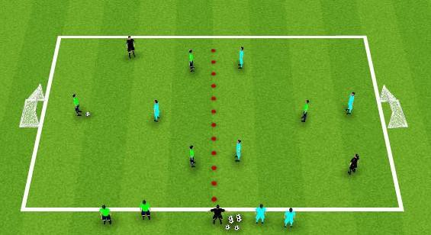
U6s 3v3 & U7s&U8s 4v4
The focus of this Small Sided Game is to foster real time decisions and allow the players to PLAY
Encourage: Spreading Out in a Diamond or Triangle for U6s
Staying High/Wide/Deep
Keep their heads UP
Of Note:Restarts from own end after goal Opposing team backs up past center line Kick ins when Ball goes out & First Pass is Free

